Appendix S1. Additional information on the Spatial Autoregressive Models.

S1.1. Steps to evaluate the effects of spatial autocorrelation on the estimation of the direct effects of habitat features, fruit abundance and bird abundance on seed dispersal.

Step 1 | Checking for significant spatial autocorrelation in the residuals of the multiple regression models that related seed dispersal to habitat features, fruit abundance and bird abundance, using Moran’s I correlograms¹. Fitting of these multiple regressions did not remove all of the spatial autocorrelation in seed dispersal (S1.2).
Step 2 | Fitting simultaneous autoregressive models (SAR²). SAR models augmented the multiple regressions with an additional term that accounted for patterns in the response variable that were related to values in neighbouring locations. They provided partial regression coefficients that represented the direct effect of each predictor free of the analytical constraints due to the spatial structure of the data (S1.3).

¹ Legendre, P. and Legendre, L. 1998. Numerical ecology. Elsevier, Amsterdam.
² Keitt, T. H., O. N. Bjornstad, P. M. Nixon, and S. Citron-Pousty. 2002. Accounting for the spatial pattern when modeling organism-environment relationships. Ecography 25:616-625.
S1.2. Correlograms representing the Moran’s I spatial autocorrelation values at different sampling distances, for the residuals of the multiple regression models (squares), and the residuals of the simultaneous autoregressive models (circles). Both models considered habitat features, fruit abundance and bird abundance, as predictor variables, and the frequency of occurrence of dispersed seeds (number of seeds per trap in the Patagonian forest) as response variable, in the three studied ecosystems. Correlograms were built by considering fifteen (twelve in the Patagonian forest) distance classes of a similar number of points. Solid figures indicate significant Moran’s I values (p < 0.05 after sequential Bonferroni correction). Note that the significant spatial structure in the model residuals disappears in all cases after applying the SAR model.
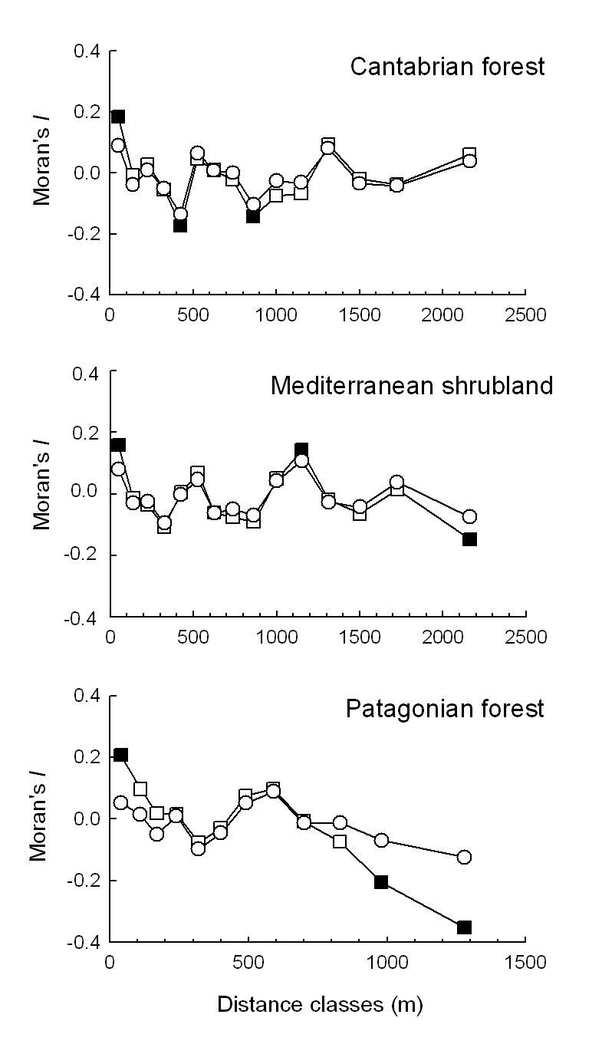
S1.3. Results of multiple regressions and spatial simultaneous autoregressive (SAR) models verifying the effect of habitat features, fruit abundance and bird abundance on the proportion of samples with dispersed seeds per plot ( Cantabrian forest and Mediterranean shrubland) or the number of seeds per trap (Patagonian forest). The values of the partial regression coefficients, their associated t-values and degrees of significance, and the proportion of variance explained by the explanatory variables independently of the spatial structure (R²) are also shown for each type of modes. SAR models were performed with SAM 3.0 software¹.

 | Multiple regression models |  |  |  | Spatial simultaneous autoregressive models
 | coefficient (+SE) | t value | p | R² | coefficient (+SE) | t value | p | R²
Cantabrian forest |  |  |  | 0.770 |  |  |  | 0.765
Forest | 0.61 + 0.06 | 8.44 | <0.0001 |  | 0.63 + 0.07 | 8.67 | <0.0001
Fruits | -0.001 + 0.01 | -0.14 | 0.890 |  | -0.002 + 0.01 | -0.21 | 0.837
Birds | 0.06 + 0.01 | 3.51 | 0.001 |  | 0.05 + 0.02 | 3.13 | 0.002
Mediterranean shrubland |  |  |  | 0.434 |  |  |  | 0.417
Forest | 0.12 + 0.13 | 0.81 | 0.422 |  | 0.05 + 0.14 | 0.38 | 0.707
Shrub | -0.22 + 0.10 | -1.93 | 0.057 |  | -0.19 + 0.11 | -1.76 | 0.082
Fruits | 0.07 + 0.01 | 4.91 | <0.0001 |  | 0.06 + 0.01 | 5.34 | <0.0001
Birds | 0.06 + 0.02 | 4.23 | <0.0001 |  | 0.07 + 0.02 | 3.66 | <0.0001
Patagonian forest |  |  |  | 0.447 |  |  |  | 0.437
Forest | 0.32 + 0.16 | 2.41 | 0.073 |  | 0.37 + 0.18 | 2.01 | 0.048
Shrub | 0.43 + 0.20 | 1.79 | 0.079 |  | 0.36 + 0.21 | 1.76 | 0.083
Fruits | 0.23 + 0.04 | 5.38 | <0.0001 |  | 0.20 + 0.04 | 4.98 | <0.0001
Birds | 0.24 + 0.11 | 2.90 | 0.047 |  | 0.26 + 0.12 | 2.11 | 0.038

¹Rangel, T. F., J. A. Felizola Diniz-Filho, and L. M. Bini. 2006. Towards an integrated computational tool for spatial analysis in macroecology and biogeography. Global Ecology and Biogeography 15:321-327.
Appendix S1. Additional information on the Structural Equation Models. Standardized coefficients of direct, indirect and total effects of habitat features, fruit abundance and bird abundance on seed dispersal (proportion of samples with dispersed seeds per plot in the Cantabrian forest and Mediterranean shrubland, and number of seeds per trap in the Patagonian forest). Total effects are calculated as the sum of direct and indirect effects. Indirect effects are calculated as the sum of products of the coefficients along all possible routes from the explanatory variable to seed dispersal.

Cantabrian forest
 | Direct effect | Indirect effect | Total effect
Forest | 0.69 | 0.17 | 0.86
Via Fruits-Birds |  | 0.06
Via Birds |  | 0.11
Fruits | 0.00 | 0.07 | 0.07
Via Birds |  | 0.07
Birds | 0.24 | 0.00 | 0.24
Mediterranean shrubland
 | Direct effect | Indirect effect | Total effect
Forest | 0.00 | 0.12 | 0.12
Via Shrubs |  | -0.02
Via Shrubs-Fruits |  | 0.02
Via Shrubs-Fruits-Birds |  | 0.01
Via Birds |  | 0.11
Shrubs | -0.15 | 0.19 | 0.04
Via Fruits |  | 0.14
Via Fruits-Birds |  | 0.05
Fruits | 0.43 | 0.13 | 0.56
Via Birds |  | 0.13
Birds | 0.39 | 0.00 | 0.39
Patagonian forest
 | Direct effect | Indirect effect | Total effect
Forest | 0.18 | -0.24 | -0.06
Via Fruits |  | -0.24
Via Fruits-Birds |  | 0.03
Via Birds |  | 0.03
Shrubs | 0.19 | 0.00 | 0.19
Fruits | 0.59 | 0.08 | 0.66
Via Birds |  | 0.08
Birds | 0.17 | 0.00 | 0.17

