TITLE OF CASE

Student1 Name Surname  Student2 Name Surname  Student3 Name Surname  Student4 Name Surname  Student5 Name Surname | Tutor: Name Surname  University of City (Country)

ABSTRACT:
The abstract is a brief text that identifies the company, institution or entity to which the case is referred as well as includes a brief description of the marketing action undertaken by it which, according to the opinion of the authors of the work, it is remarkable due to its utopian character.
You can also refer to any short indication as, for example, the objectives aiming such marketing action, its target audience, etc. or even a preview on the findings and/or judgements, but not bibliographical references (which will be reserved for the main body of the text), and taking into account that the full length of the introductory paragraph or paragraphs should not exceed 10 lines in accordance with the spacing and font set forth in this template.

RESUMEN:
Text in Spanish (co-official language of the Congress) that should correspond to a translation as faithful as possible to the previous abstract. Please note that even when in this kind of translations Spanish version is usually longer that the English version, the maximum length is 10 lines.
If you do not speak Spanish or you are not very confident with your proficiency, the Organizing Committee will assist you by either reviewing the text or directly arranging it for you (just leave it blank).
Line 8
Line 9
Line 10

1. INTRODUCTION
In the introductory section you should indicate the name of the company, institution of entity to which the case is referred, as well as provide the information or data required to provide the potential reader a clear idea on its activities, goals, etc.
As an example, you could tell here on the time and/or place of its foundation, the name of the founder or founders, the activities performed and/or the products that it puts in the market, any significant changes that could affect the business or activities and the reasons to undertake them, and so on.
At that purpose, please note that nowadays a vast majority of business enterprises, public institutions and nonprofit entities have a website where you can easily find this kind of information.
Consider, in any case, that the intended purpose is not replicating “literally” information from the Internet sites, but choosing the most relevant data or facts and presenting them consistently.
An appropriate extension (suggested) for the introductory section could be 1 or 2 pages, even including some chart or table to increase the attractiveness of the text. In this sense, an easy alternative would be to reproduce the website to which references are being made (see the example format as shown in Figure 1, including the date when the image was available on the net).
Finally, and although not strictly required, it is advisable that graphics and/or tables are inserted at the top or at the bottom of the page where reference is made to them (rather than in the middle of the page).

Figure 1. Initial screen from the official website of PLAYMOBIL®.

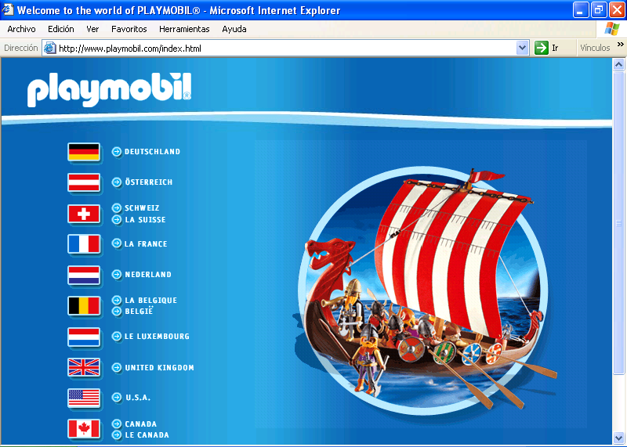

Source: [http://www.playmobil.com], as available at 12/01/2005.

2. CASE DEVELOPMENT:
In a second section you should indicate the activity within the marketing policy of the respective company, institution or entity that stands out due to its utopian nature.
As in the previous section, you should include information or data enough to allow the potential reader a clear picture of the concrete activity, its target group/s, the purpose o purposed that are intended or wanted to be achieved with it, the moment when was initiated and, where appropriate, when it was concluded, those results achieved, and so on.
An appropriate extension (suggested) for this section of the text could range between 3 and 5 pages length, including charts of graphics included to illustrate the text, either if “own elaborated” or reproduced from any bibliographical source.
In the latter case, as in any other place where including bibliographical citations in the text, these will be in parentheses and following the “author and year” system, just as shown in this example (Surname, 2009). There may also be excerpts from contributions by two authors, then referred as (Surname1 and Surname2, 2009), or by three or more (Surname1 et al., 2009). Tutor teachers will probably solve you any doubt in this regard, as they are used to this way of citing references.
Figure 2 shows another example of chart format.
You may want to include one or more subsections. If so, please use the bold format as indicated below (without blank lines between).

Example of subsection heading:
As you can see, after the subsection heading the text continues normally and according to the same format style.

Figure 2. Reasons for the importance of implementing a marketing plan.

Source: Author’s own elaboration on the basis of Lambin (1993).

3. QUESTIONS FOR DISCUSSION:
As it is usual in teaching cases, a third section will include 3 to 5 questions that, according to the authors’ opinion, serve to stimulate the critical spirit of potential readers and encourage them, where appropriate, to go further and/or deeper in the case content.
The recommended extension for this section is from 1 to 2 pages.
Question 1. Ask the question clearly and accurately
Include here some indications for the response and possible further discussion. These indications should be based on the evidence introduced in the previous text, as well as other possible information gathered during the development of the case.
In this sense, the link between theory and practice will be particularly valued, proving the domain in the public and/or non-profit field of knowledge on marketing or other related disciplines of application. For this purpose, it may be possible to use citations of those authors or materials that may be more appropriate.
Question 2. Ask the question clearly and accurately
Question 3. Ask the question clearly and accurately

...

4. CONCLUSIONS:
Afterwards, you could also like to include any reviews, comments and suggestions or contributions reflecting authors’ own critical opinions, either praising the action that was taken and its opportunity, indicating alternatives or suggestions for improvement, etc.
In short, you are not required to properly answer the questions for reflection just after stating them, but much more to argue on the reasons for choosing the concrete marketing action or actions as good examples of utopian character.
The suggested length for this section as a whole ranges from 1 to 2 pages.

REFERENCES
Kotler, P. (1988): Marketing management: analysis, planning, implementation and control. 6th ed. Englewood Cliffs (New Jersey): Prentice-Hall.
Levitt, T. (1980): Marketing success through differentiation of anything. Harvard Business Review 58(1): 83-91.
Playmobil (2005): company official website [http://www.playmobil.com], available at 12/01/2005.
Santesmases Mestre, M. (2004): Marketing. Concepts and Strategies. 5th ed. Madrid: Pirámide.
...

(Note: These above are just only a few examples allowing distinction on quoting a book, an article or a website. Professors may solve any further questions on this subject, as being used to the different ways and styles when quoting bibliographical references).

