MAIN THEME: ____________________________________________________

TITLE OF THE ESSAY: _____________________________________________________________________

AUTHORSHIP:
- Author’s 1 name and surname, Full affiliation, ORCID email (optional)
- (optional) Author’s 2 name and surname, Full affiliation, email.
- (optional) Author’s 3 name and surname, Full affiliation, email.

DeclaraTION of authorship and originality: This document has not been published before nor is it in process of being published, it is an original creation, with no conflict of interest, the authenticity of the information is author’s 1 responsability and its publication is authorised in the frame of the II International Conference Adult Education for Employment and Inclusion CyLAEI 2022.

abstract
First, make sure to register the authors in www.unioviedo.es/cylaei. Write here about 200 words describing the tackled theme, the work context, the aims you planned, the procedure and method used in the investigation or experience, the achieved information and the importance of this contribution for the scientific community, for other teachers, for educational administration or any other specific related section. Send it to cylaei@uniovi.es before February, 28th 2022 to be accepted. The text will be in editable .doc, .docx, .odt, in Times New Roman letter size 12 points, single-spaced, upper margin 3,5 cm, and for the rest of the margins 3 cm. Do not send documents in PDF format. Letters in tables can be in a different size. Except in those cases authorised by the Conference organization and linked to the importance of the shown experience, the complete text do not have to exceed 4000 words and 8 pages. Keep this template with its head, do not use footnotes or numbering at the bottom of the page. You can use Spanish or English for the whole text. Do not forget that your contribution must be interesting and tackle an experience or research already practised with a successful result, related to adult education.
.
KEYWORDS: Minimum 4 lowercase letter words, separated by semicolon.

1. introducTION
Similar and extended abstract text. It can have facts that help to contextualize the paper and some other previous information of the tackled case. Do not forget that this document can be read by people all over the world who do not know the specific environment of your experience.

2. Justification and interest of the theme
Detail why and to whom that theme or specific problem had to be tackled. Or in other case, indicate the actual lack of knowledge about that topic.

3. STATUS OF THE ISSUE
It is important to investigate and describe the STATUS OF THE ISSUE where a revision of previous and similar papers already carried out will be done or/and of the scientific literature related to your contribution.

4. OUTLINED AIMS
Describe what you wanted to achieve with this paper, in other words, the aims you have planned (do not forget that in the result section you must give facts about the achievement of those aims).

5. METHOD
Indicate the procedure you have followed to solve the problem or lack of knowledge you had detected and the way to find the solution. In other words, describe the methodological design you had initially planned, if you do a paper mainly descriptive, or if you do an experimental experience or any other procedure.
5.1. Sample, phases, spaces, work times (Second level epigraph)
This is a second level epigraph. Here it is convenient you detail the population and the sample profile which was the aim of this paper, as well as where the experience took place, when it happened, the work phases/parts, the material and human resources implemented.
5.1.1. Third level epigraph
If it is necessary, you can use more concrete epigraphs to clarify specific aspects inside the second level epigraph. Try not to use more sublevels of paragraphs, however, you can do it.
5.2. Instruments/tools of investigation used
Detail if you have used a concrete instrument, for example, a questionnaire (it would be very interesting if you present it in the enclosures). You can indicate the levels of rigour of this tool and the procedure of implementation, fiability and validity.

6. RESULTS
Indicate here the information you got, how you have analized it, the evaluation of results in relation to the initial outlined aims you had planned.

Figure 1. Only self-elaborated figures are accepted or if the original source is properly indicated. Placed in the right space inside the text and not at the end of the document.

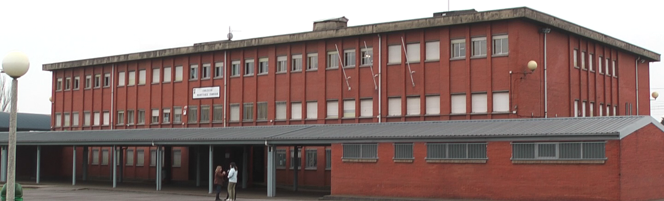

7. DISCUSSION
In this part an assessment of the importance of the obtained results must be done, comparing them to the previous situation and/or with the existing scientific literature.

Table 1. Títle ____________________________________________
(The table format can be slightly modified if necessary)

 | Text | Text | Text
Text | 1 | 3 | 1
Text | 2 | 3 | 9

8. LimitS OF THIS PAPER
In this part, analize the limits this work could have, possible bias, problems to generalize the results, etc.

9. conclusionS AND CONTRIBUTIONS
Here you must specify the main discoveries and contributions. It is important to clearly explain the specific aspects that mean an improvement for teachers, scientific community, professionals or any other particular aspect.
.

10. SUPPORTING InformaTiOn
Indicate the WEB links or any other complementary supporting information.

THANKS AND FACTS OF THE PROYECT
Say thanks and facts of the proyect (only if necessary).

REFERENCES
(List here only the mentioned references in the text, following the APA 7 format).
Examples:
Jurado de los Santos, P.; Moreno-Guerrero, A.-J.; Marín-Marín, J.-A. & Soler Costa, R. (2020). The Term Equity in Education: A Literature Review with Scientific Mapping in Web of Science. International Journal of Environmental Research and Public Health, 17(10), 3526. MDPI AG. http://dx.doi.org/10.3390/ijerph17103526
López-Belmonte, J.; Marín-Marín, J.; Soler-Costa, R. & Moreno-Guerrero, A. (2020). Arduino Advances in Web of Science. A Scientific Mapping of Literary Production. IEEE Access, 8, 128674-128682. https://doi.org/10.1109/access.2020.3008572

APPENDICES
In this section you add complementary facts that help to understand the paper: used questionnaires, deep description of facts you got, etc.

