thematic axis: ___________________________________________________

POster/Infographic
In the event that your contribution does have a high visual component, you are allowed to submit a poster or computer infographic. Firstly, make sure you register the author in www.unioviedo.es/cylaei, and subsequently, send your contribution to cylaei@uniovi.es in PDF format, prior to 28th February 2022, as a preliminary step to the acceptance of your essay. Being your piece of work of explanatory nature, it will have to adjust to the structure of a scientific input as described in the sections below.
Where possible, your essay will focus on presenting significant graphical elements or additional illustrative elements. Please, take great care over picture composition. If you do not wish to submit your document in this format, do not hesitate to turn in a text-based communication. Do not forget that the gist of this document resides in the picture. Otherwise, make a choice in favour of a text-based communication.

Additionally, the following issues must be taken into account:
- Our electronic mail does not support large size files.
- The author of the document is bound to use his/her own pictures since other people´s pictures should require the proper authorization.
- As a participant in the Conference, the author of the paper cedes the rights for public dissemination to the Conference.
SEE THE EXAMPLES ON THE PAGES THAT FOLLOW:

All FOUR fields must be completed.

1. TITLE: ____________________________________________________________

2. AUTHORÍA:
- Name and Surname author 1, Full affiliation, email ORCID (optional)
- (optional) Name and Surname author 2, Full affiliation, email.
- (optional) Name and Surname author 3, Full affiliation, email.

3. STATEMENT OF AUTHORSHIP and ORIGINALITY: This document has not been published before nor is it in process of being published, it is an original creation, with no conflict of interest, the authenticity of the information is Author 1´s responsibility, and its publication is authorised in the frame of the Second International Conference on Adult Education for Employment and Inclusion CyLAEI 2022.

4. eASILY LEGIBLE GRAPHIC DESIGN WITH THE ENSUING CONFERENCE LOGO:
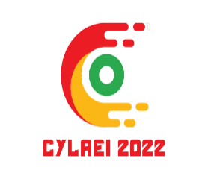
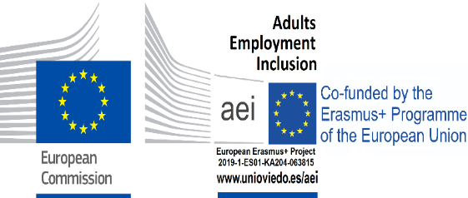
2nd International Conference Adult Education for Employment and Inclusion (CyLAEI 2022)
www.unioviedo.es/cylaei

The following information must be attached into the poster/infographic:

keywords: 3 to 5 lowercase words and separated by semicolons.

Justification and interest of the topic
Please, detail why and for whom that theme or specific problem had to be dealt with. Or alternatively, indicate the current lack of knowledge about the topic.

Objectives
Please, show the goal you have pursued with this piece of work, in other words, what your main objectives are and which of them have been achieved.

METHOD
Please, describe the procedure you have followed to tackle the problem or lack of knowledge detected, and the way to find a solution to it. In other words, describe the methodological design initially planned.

RESULTS
Please, show the information gathered, the way it´s been analised and the assessment of results in relation to the initial set objectives.

conclusions and CONTRIBUTIONS
Please, you can show the main discoveries and contributions in your essay. It is important to clearly note the specific aspects that mean an improvement for teachers, for the scientific community and for professionals, or any other point to be considered.

Examples of Poster/infographic:

