MAIN THEME: _________________________________________________
Firstly, make sure you register the authors in www.unioviedo.es/cylaei. Secondly, upload your video communication to the online platform YOUTUBE and, after that, send the link to the email address cylaei@uniovi.es, prior to the 28th February 2022, (please, don´t submit videos by other means). Keep your video posted in YOUTUBE until at least 10th July 2022.
Being the video of explanatory nature, it will have to adjust to the structure of a scientific input, as described in the sections below.
Where possible, the video will be supported by graphics or additional illustrative elements, as well as by the author or authors´ image. Do not forget that the gist of this video resides in featuring a meaningful image. Otherwise, make a choice in favour of a text-based communication.

In its simplest form it can be a “selfie” of the author with the support of a blackboard or a Power Point presentation converted into a video (File, Export, Create a video, Portable Presentation), where the author inserts a video describing the content of his/her research. Be aware that online platforms do not support large size files, therefore it´s advisable to use low resolution when recording.

The use of your own pictures is recommended since other people´s pictures should require the proper authorization. As a participant in the Conference, the author of the paper authorises public dissemination in the frame of the Second International Conference on Adult Education for Employment and Inclusion CyLAEI 2022.

The duration shall not exceed ten minutes. A correct composition of the image, -separating the foreground from the background-, and a clear speech – using fairly short sentences-, would be very much appreciated for the sake of language translation. If you do not wish to submit your document in this format, do not hesitate to turn in a text-based communication.

All FOUR fields must be completed.

1. TITLE: _________________________________________________________

2. AUTHORSHIP:
- Author 1’s name and surname, Full affiliation, ORCID email (optional)
- (optional) Author 2’s name and surname, Full affiliation, email.
- (optional) Author 3´s name and surname, Full affiliation, email.

3. Graphics with the DECLARATION OF AUTHORSHIP AND ORIGINALITY:
This document has not been published before nor is it in process of being published, it is an original creation, with no conflict of interest, the authenticity of the information is Author 1´s responsibility and its publication is authorised in the frame of the Second International Conference on Adult Education for Employment and Inclusion CyLAEI 2022.

- eASILY LEGIBLE GRAPHIC DESIGN WITH THE ENSUING CONFERENCE LOGO:
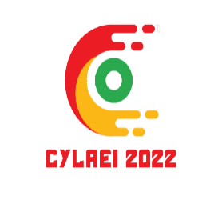

2nd International Conference Adult Education for Employment and Inclusion (CyLAEI 2022)
www.unioviedo.es/cylaei

The following information is required along with the video communication.

brief summary
Very brief speech on the key points of your contribution.

1. introduction:
(A extensión of the summary providing data that help contexualise the contribution. Do not forget that the document may be viewed by people from all over the world who are unfamiliar with the specific environment of your experience).

2. Justification and interest of the theme:
Detail why and for whom that theme or specific problem had to be dealt with. Or alternatively, indicate the current lack of knowledge about the topic.

3. STATUS OF THE ISSUE
Brief review of the scientific literature linked to the contribution and/or to previous research.

4. SET OBJECTIVES:
Make a description of the goal you have pursued with this piece of work, in other words, what your main objectives are and which of them have been achieved.

5. METHOD:
Describe the procedure you have followed to tackle the problem or lack of knowledge detected, and the way to find a solution to it. In other words, describe the methodological design initially planned.
5.1. Sample, stages, spaces, work times (Second level epigraph)
In this section you should give details about the population and the sampled profile which was the target of your paper, as well as information about when and where the experience took place, the various stages of the process and, eventually, the material and human resources implemented.
5.2. Research tools/instruments used.
State if you have made use of a specific tool, namely, a questionnaire, and its accuracy level, reliability and validity, together with the procedure for its implementation.

6. RESULTS
Specify here the information gathered, how you have analysed it and finally, the assessment of results in relation to the initial set objectives.

7. Limitations/ restrictions to your contribution.
You should analyse the constraints that may limit your work, the potential bias, the problems with generalising the results, etc.

8. conclusionS AND CONTRIBUTIONS
You must list here the main discoveries and contributions in your essay. It is important to clearly note the specific aspects that mean an improvement for teachers, for the scientific community and for professionals, or any other point to be considered.

.

REFERENCes:
(The references can be included at the end, in a graphic design, following the APA 7 format)
Examples:

Jurado de los Santos, P.; Moreno-Guerrero, A.-J.; Marín-Marín, J.-A. & Soler Costa, R. (2020). The Term Equity in Education: A Literature Review with Scientific Mapping in Web of Science. International Journal of Environmental Research and Public Health, 17(10), 3526. MDPI AG. http://dx.doi.org/10.3390/ijerph17103526
López-Belmonte, J.; Marín-Marín, J.; Soler-Costa, R. & Moreno-Guerrero, A. (2020). Arduino Advances in Web of Science. A Scientific Mapping of Literary Production. IEEE Access, 8, 128674-128682. https://doi.org/10.1109/access.2020.3008572

The inclusion of explanatory figures is highly recommended, either your own or others where the original source is properly identified..
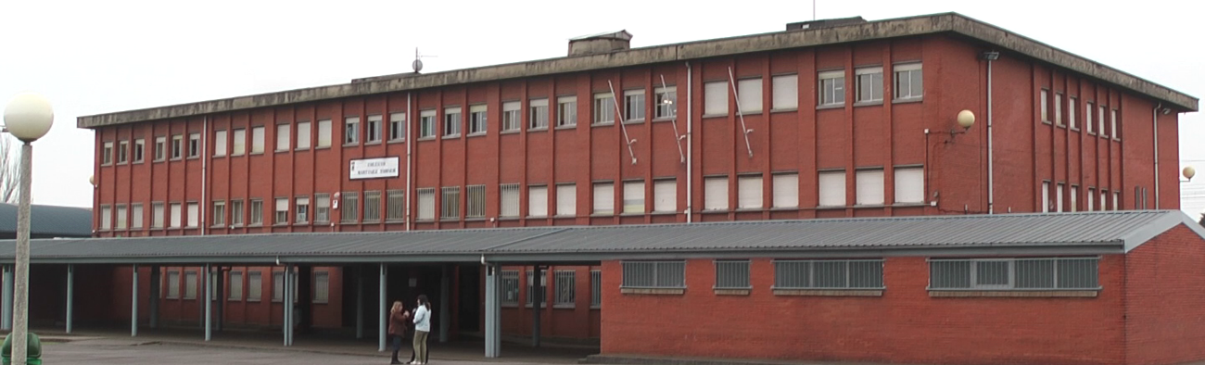

It is advisable to insert tables (in any format of your choice).

 | Text | Text | Text
Text | 1 | 3 | 1
Text | 2 | 3 | 9

