Sharing good educational practices and systematising a training competences programme for employment and inclusion for vulnerable adult people! Erasmus+ project 2016-2018
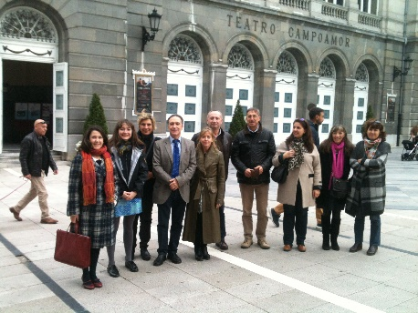
Kick off meeting in Oviedo on November 9-10th 2017
The main work plan and next project's steps and activities were identified on the 1st meeting hosted by the coordinator of the project Universidad de Oviedo. Cultural and historical visits were also organized for all partners. After this first meeting, the best practices questionnaire was drafted and submitted among teachers in all partner countries.
Partners : UOv (Spain); UAb (Portugal), CPIA (Italy), CEPA (Spain) and E-Seniors (France)

The first training week for teachers took place in Padova on March 20-24th 2017
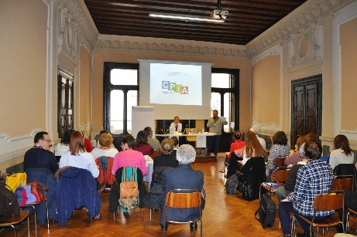
Participants from all partner countries were involved in different roundtables and discussions on topics such as "Effective communications", "Main competencies for collaborative work", "ICT Audiovisuals as effective educational support resources" and many others. At the end of the week, all participants answered a satisfaction survey in order to evaluate the trainings.

The second training week for teachers took place in the city of Gijon on July 3-7th 2017
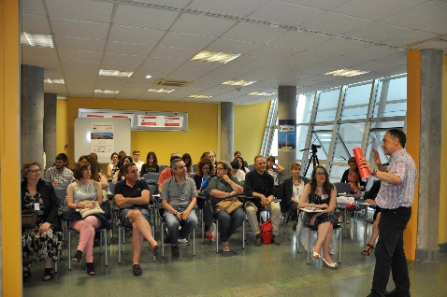
Participants attended different trainings on "Entrepreneurship and Employment", "Work in team", "Mentoring, coaching and differences between them", "ICT" and many others. Cultural and historical visits were also organized during the week.
Main outcomes from the Year 1:
- Creating a worldwide base of institutions dedicated to the training of adults https://www.unioviedo.es/ei/net.html
- Participating in several scientific conferences and congresses disseminating this experience
- Creating Videos Youtube https://youtu.be/aSCt3tixaXg
https://youtu.be/tqLj2pLzroM and broadcasting videos for Television.
- Implementing a Portfolio with our educational materials https://www.unioviedo.es/ei/material.htm
- Spreading awareness the training of adults as a solution to the problems of social inclusion and unemployment.

